Name: _____________________________________
Plate Tectonics
Questions for Section 2-1: Where Are the Volcanoes and Earthquakes?
- Be able to define all of the vocabulary words found in your powerpoint. Unless you chose to, you do not have to define them in writing here. I would recommend writing them somewhere at some point.
- What are the 3 major layers of the earth? How do they differ from each other?
- What are the two types of crust?
- What are the two layers that include mantle? How do they differ in composition and “behavior.”?
- What is this picture outlining? Why are they important?
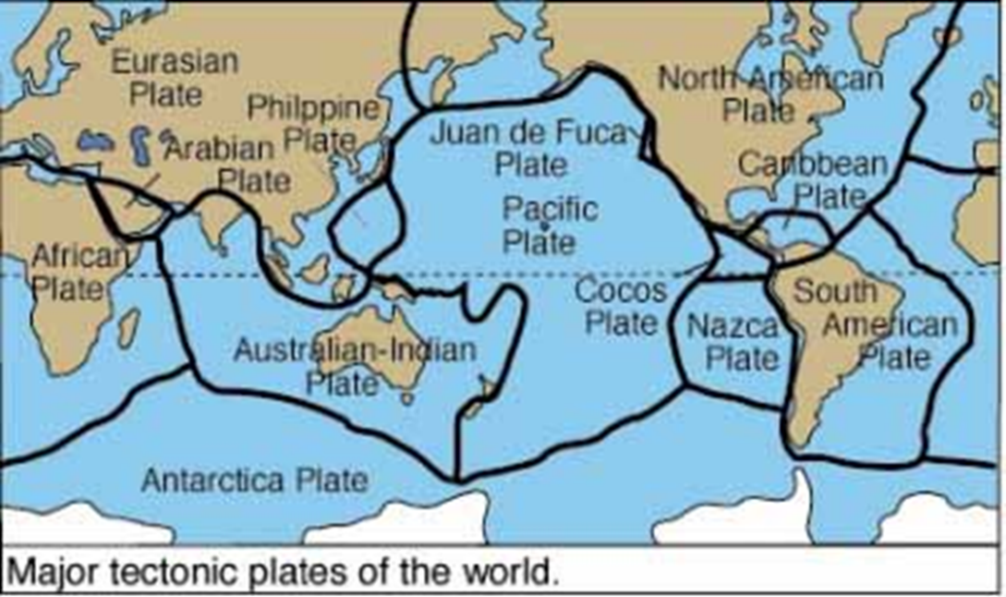

- What is happening at a convergent plate boundary?
- What are the three types of convergent plate boundaries and what are the plates doing? What is the result of each type of convergent plate boundary?
- Compare and contrast magma and lava.
- What is occurring at a divergent plate boundary? What is the result?
- What is occurring at a transform plate boundary and what is the result?
- Discuss the mid-oceanic ridge and why geologists consider it important.
- Why are volcanoes more common underwater?
- What are the tectonic plates doing at “the ring of fire?” Why is it called the ring of fire?
- Discuss how a seismograph might work.
- Contrast an epicenter and a focus of an earthquake.

