Name: ______________________________
Hour: 3 6 8
Write the letter indicated by each picture in the space next to the correct name of the piece of laboratory equipment on the page that follows.
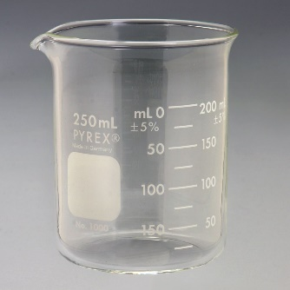
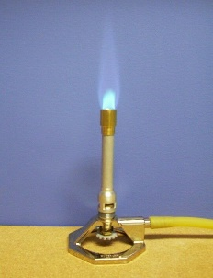
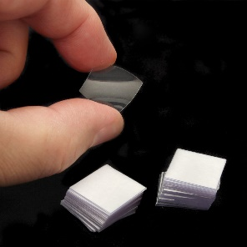
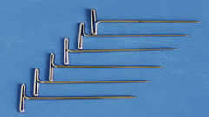
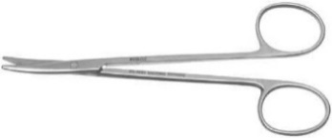
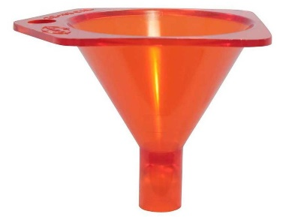
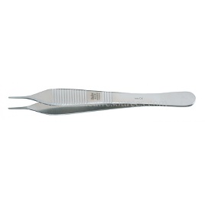
M
N
G
H
A

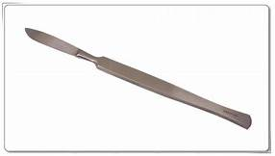
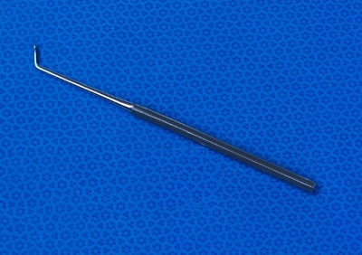
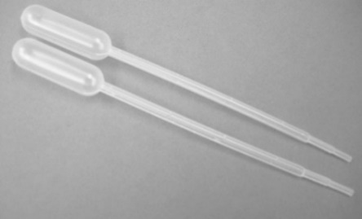
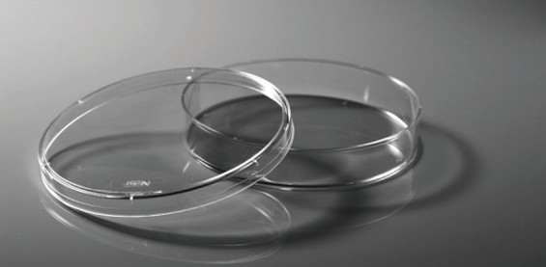
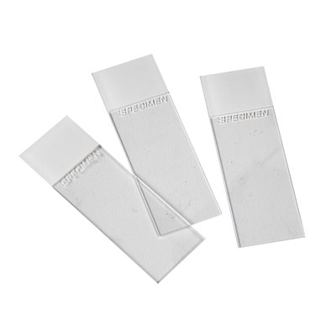
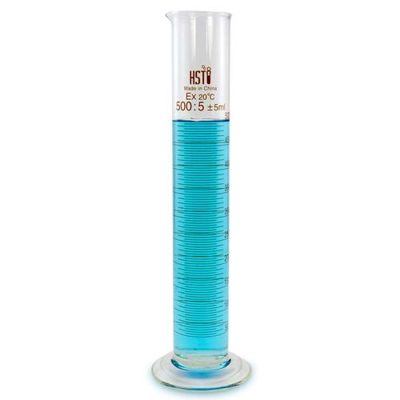
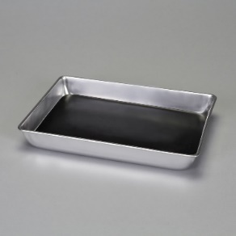
J
K
I
F
E
B
C
D
L
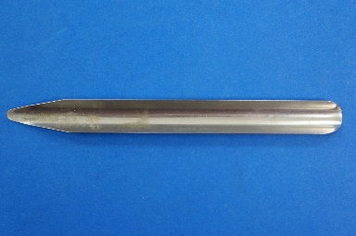
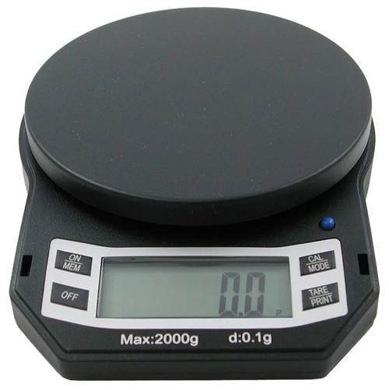
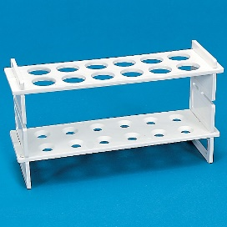
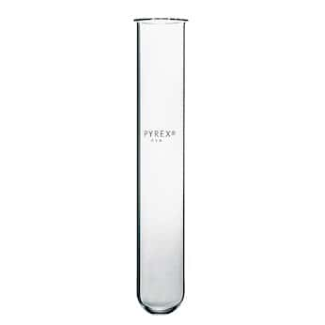

R
O
Q
P
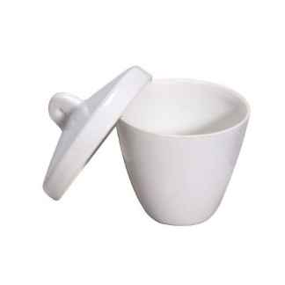
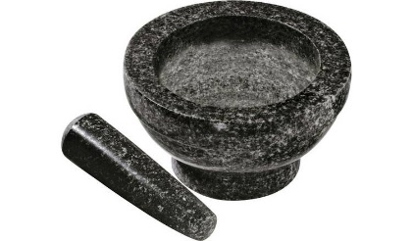
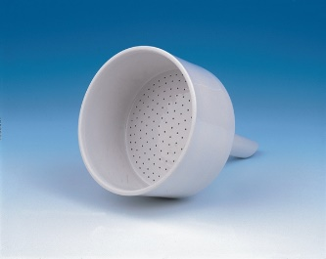
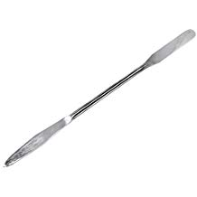
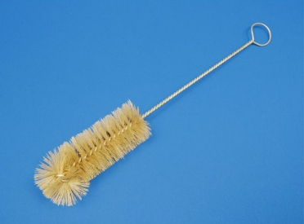
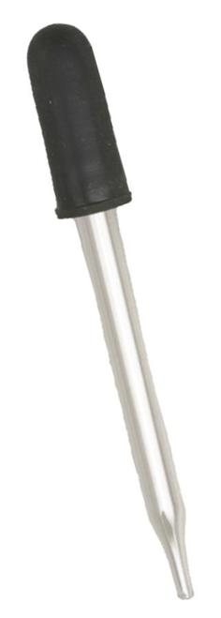
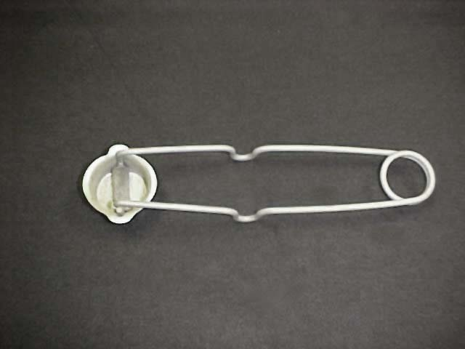
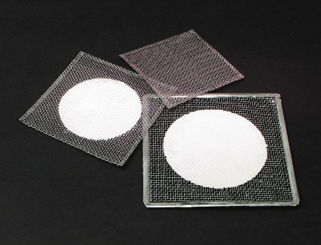
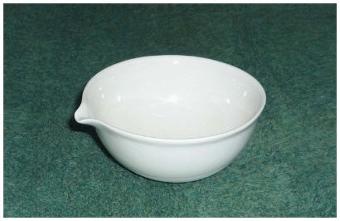
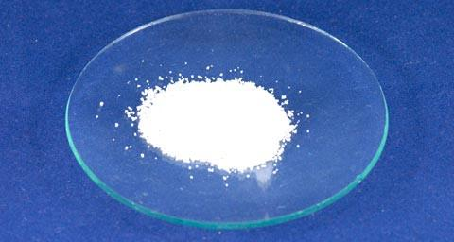
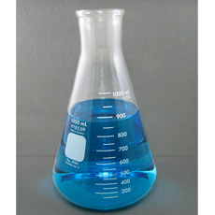
DD
CC
BB
AA
Z
Y
X
W
V
U
T
S
Part A: Use the lines that follow to write the appropriate letter(s) that identify the correct piece of laboratory equipment.
- Erlenmeyer flask _______________
- Dissecting pan ________________
- Scoopula _______________
- Buchner funnel _______________
- Test tube _______________
- Wire gauze _______________
- Test tube rack _______________
- Forceps _______________
- Medicine dropper _______________
- Scalpel _______________
- Probe _______________
- Beaker _______________
- Pipette _______________
- Watch glass _______________
- Chemical spatula _______________
- Mortar _______________
- Striker _______________
- Bunsen burner _______________
- Petri dish _______________
- Glass slide _______________
- Wire brush _______________
- Crucible _______________
- Digital scale _______________
- Pestle _______________
- Funnel _______________
- Dissecting scissors _______________
- Dissecting pins _______________
- Evaporating dish _______________
- Cover slip _______________
- Graduated cylinder _______________

Part B: Please write the letter(s) of the piece of laboratory equipment that best matches the uses listed below.
- _______________Measures volume in less exact measurements by having larger jumps between markers
- _______________Measures volume in more exact measurements by having smaller jumps between markers.
- _______________spoon small amounts of chemical powder
- _______________spoon large amounts of chemical powder
- _______________maintain a flame
- _______________start a flame
- _______________hold back flaps of a dissection specimen
- _______________make small, shallow, precise incisions in a dissection specimen
- _______________large, imprecise cutting of dissection specimens
- _______________ pour liquids without spilling
- _______________ used in pressure assisted filtration
- _______________ vessel in which chemical reactions can occur and be observed
- _______________ holds test tubes upright
- _______________ vessel for holding a dissection specimen
- _______________ transfers liquids dropwise when the measurement of the drop is irrelevant
- _______________transfers small amounts of liquids when correct measurement is necessary
- _______________bowl, often made of marble, in which material can be crushed to powder
- _______________blunt instruments used to crush material into powder
- _______________used to mount microscopic specimens for examination under a microscope
- _______________used to hold microscopic specimens in place for examination under a microscope
- _______________holds vessels in place on top of a ring attached to a ringstand
- _______________vessel that allows liquids to separate and leave solids behind
- _______________measures mass
- _______________vessel with a wide bottom, but a narrow neck for pouring that can be sealed with a stopper for storage
- _______________used to pick up and move small but macroscopic pieces
- _______________used to investigate or explore small crevices in a dissection specimen
- _______________ can be a surface to evaporate a liquid, hold solids especially powders to be weighed, heat a small amount of substance or as a cover for beakers
- _______________grow cultures
- _______________clean small places, such as inside a test tube
- _______________used to hold substances that need to be heated with extreme temperatures
Part C: Answer the questions that follow.
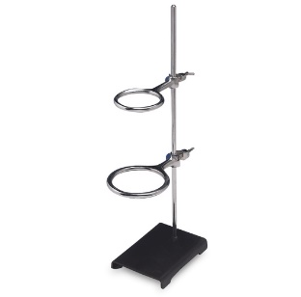
- The following is a ring and ring stand. What is its purpose?

- What is the purpose of a thermometer? _____________________________________________
- What is the purpose of a stirring rod? _______________________________________________
- Can a stirring rod and thermometer be used for the same purpose? _______________________
- Why would a test tube clamp be necessary?

What piece of equipment would you use for the following purposes? Please write the name of the piece of equipment (not just the letters).
- Measure approximately a glass of milk ___________________
- Scorch sugar ___________________
- Crush sage into powder _________________ and ___________________
- Hold a beaker on a ring attached to a ring stand _________________

