Name: ______________________________________
Hour: 3 6 8
Introductory Science Test Review Sheet
You will be able to use your conversion sheet and a calculator on the test. Please bring these materials to the test.
You should be able to:
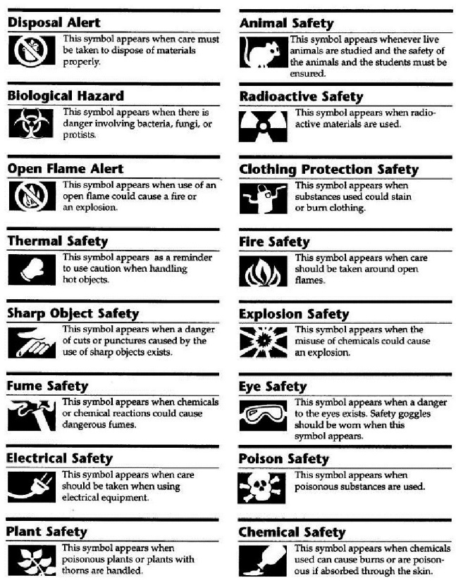
- Look over your Flynn Scientific Safety Contracts and recall common sense rules on lab safety discussed in class.
- Be able to identify lab safety symbols.

- convert a small decimal or large number to scientific notation
  - 0.0005670 =

  - 180900000000=
- convert a number in scientific notation to a small decimal or large number
  - 3.20 x 10⁻⁹

  - 1.5 x 10⁴

- convert and interpret e notation.
  - 86 e -5=

  - 52,000,000=
- describe why scientists use scientific notation

- convert a number to the appropriate number of significant digits. Round the following to 4 significant digits:
  - 0.0980120

  - 14090101000

- use the rules of significant digits. For each of the following numbers, state the rule that indicates to you if the number is significant or not and state whether or not it is significant: 0.0050670
  - 0

  - 0

  - 5

  - 0

  - 6

  - 7

  - 0

- describe why scientists use significant digits?

- convert measurements within the metric system. You should show your work and a process.
  - 0.0000894 dam= _______________ mm

  - 0.0261 g = _____________cg

  - Fabio wants to know if his 7 kL flask will be able to hold the 35 mL that he wants to pour into it. If it will, how many more mL could he pour into it?

- convert measurements between the metric system and the American System of Units. You should show your work and a process.
  - ____________ g = 0.1433 ton

  - ____________tsp = 1.2 pts

  - The singular subbie swimmer has been asked to swim 1.40 miles. There are 75 m in each lap. How many laps does she need to swim?

- identify and provide uses for the laboratory equipment presented in class. Please use the identifying lab equipment paper to help you do this. Also, be able to answer questions on names of microscope parts and uses.

- choose the correct graph type for a given set of data
  - The freezing temperature of water contaminated with salt, sugar, charcoal and uncontaminated ______________
  - The number of students majoring in every type of engineering in the department ______________
  - The comparison of the height of an individual with a bone disease across his lifetime compared to the height of an individual without bone disease. _______________

- construct a graph from data using all the steps of graphing
  - Mom and Pop’s Video Rental Store only has 5 categories of movies to rent: Comedy, Action, Romance, Drama and SciFi. They are interested in comparing the number of videos rented in all of the categories found in their store on a Friday night, their busiest night, to determine where they should spend the most money to buy more videos. Using the data provided below, construct the graph that best displays the data using all the steps of graphing.
Category | # of rentals
Comedy | 4
Action | 5
Romance | 6
Drama | 1
SciFi | 4

- identify the independent and dependent variables and control and experimental groups. Use the following scenarios for practice.
  - Hypothesis: If a food item has more additives and preservatives, than it will be less nutritious.

  - If fertilizers and growth enhancers are provided to plants, than they will not grow any more than if they are. To test this, fill two pots with potting soil. Plant one bean (mung bean, green bean or pea) in each pot. Place the pots in a location so that both are exposed to the same amount of sunlight and the same temperature. Add a fertilizer or growth stimulant to one pot. Apply the same amount of water daily to each pot. Measure the plants and observe their health each day. Record your data and conclude whether fertilizers have a positive, negative or no effect on plant growth. Try conducting this experiment with different species of beans and different fertilizers or growth enhancements. The light, water, soil and temperature variables should be constant for each experiment. Conclude as to whether fertilizers and growth enhancements are beneficial or not.

- identify confounding variables and discuss how they would be handled. Use b above as an example.

- discuss your opinion on pure vs. applied science and their importance.

